EXP:3 | Setting Up Hybrid Cloud Connectivity Using Cisco Packet Tracer
22/7/2026

AIM
To simulate a secure hybrid cloud connection between an on-premises data center and a cloud network using routers, switches, subnets, and routing in Cisco Packet Tracer.

SOFTWARE / COMPONENTS REQUIRED
- Cisco Packet Tracer
- Two Cisco 2911 routers
- Two Cisco 2960-24TT switches
- One PC
- One Server
- Copper Straight-Through cables
- Copper Cross-Over cable for the router-to-router link

NETWORK TOPOLOGY
The simulated network consists of an on-premises LAN connected to a cloud/server LAN through two routers. Static routing is used between the two networks.

PC0 | → | Switch0 | → | Router1
Router1 | → | 10.10.10.0/30 | → | Router2
Router2 | → | Switch1 | → | Server0
PC Network | → | 192.168.1.0/24
Server Network | → | 10.0.0.0/24

IP ADDRESSING TABLE

Device | Interface | IP Address | Subnet Mask | Purpose
Router1 | GigabitEthernet0/0 | 192.168.1.1 | 255.255.255.0 | On-premises LAN gateway
Router1 | GigabitEthernet0/1 | 10.10.10.1 | 255.255.255.252 | Router-to-router link
Router2 | GigabitEthernet0/0 | 10.0.0.1 | 255.255.255.0 | Cloud LAN gateway
Router2 | GigabitEthernet0/1 | 10.10.10.2 | 255.255.255.252 | Router-to-router link
PC0 | FastEthernet0 | 192.168.1.10 | 255.255.255.0 | On-premises host
Server0 | FastEthernet0 | 10.0.0.10 | 255.255.255.0 | Cloud server

PROCEDURE
- Open Cisco Packet Tracer and create a new logical workspace.
- Place two 2911 routers, two 2960 switches, one PC and one Server.
- Connect PC0 to Switch0 and Switch0 to Router1 using Copper Straight-Through cables.
- Connect Server0 to Switch1 and Switch1 to Router2 using Copper Straight-Through cables.
- Connect Router1 GigabitEthernet0/1 to Router2 GigabitEthernet0/1 using a Copper Cross-Over cable.
- Open Router1 CLI. When prompted for the initial configuration dialog, enter no and press Enter.
- Configure Router1's LAN and inter-router interfaces.
- Verify Router1 interfaces using show ip interface brief.
- Open Router2 CLI and configure its LAN and inter-router interfaces.
- Configure PC0 with IP address 192.168.1.10, subnet mask 255.255.255.0 and default gateway 192.168.1.1.
- Configure Server0 with IP address 10.0.0.10, subnet mask 255.255.255.0 and default gateway 10.0.0.1.
- Configure static routes on both routers so that the two LANs can communicate.
- Verify the routing tables using show ip route.
- From PC0, use ping 10.0.0.10 to verify end-to-end connectivity.
- Save the router configurations using copy running-config startup-config.

ROUTER CONFIGURATION COMMANDS

Router1 Configuration
enable
configure terminal
interface gigabitEthernet0/0
ip address 192.168.1.1 255.255.255.0
no shutdown exit
interface gigabitEthernet0/1
ip address 10.10.10.1 255.255.255.252
no shutdown exit
ip route 10.0.0.0 255.255.255.0 10.10.10.2
exit
copy running-config startup-config

Router2 Configuration
enable
configure terminal
interface gigabitEthernet0/0
ip address 10.0.0.1 255.255.255.0 no shutdown
exit

interface gigabitEthernet0/1
ip address 10.10.10.2 255.255.255.252
no shutdown exit
ip route 192.168.1.0 255.255.255.0 10.10.10.1
exit
copy running-config startup-config

Verification Commands
do show ip interface brief show ip route
ping 10.0.0.10

OUTPUT / OBSERVATION
The following outputs were obtained during the simulation.

Router1 Interface Verification

Interface | IP-Address | Status | Protocol
GigabitEthernet0/0 | 192.168.1.1 | up | up
GigabitEthernet0/1 | 10.10.10.1 | up | up
GigabitEthernet0/2 | unassigned | administratively |  | down | down
Vlan1 | unassigned | administratively |  | down | down

Router2 Interface Verification

Interface | IP-Address | Status | Protocol
GigabitEthernet0/0 | 10.0.0.1 | up | up
GigabitEthernet0/1 | 10.10.10.2 | up | up
GigabitEthernet0/2 | unassigned | administratively |  | down | down
Vlan1 | unassigned | administratively |  | down | down

Router1 Routing Table – Static Route
S 10.0.0.0/24 [1/0] via 10.10.10.2
C 10.10.10.0/30 is directly connected, GigabitEthernet0/1 L 10.10.10.1/32 is directly connected, GigabitEthernet0/1 C 192.168.1.0/24 is directly connected, GigabitEthernet0/0 L 192.168.1.1/32 is directly connected, GigabitEthernet0/0

Router2 Routing Table – Static Route
C 10.0.0.0/24 is directly connected, GigabitEthernet0/0 L 10.0.0.1/32 is directly connected, GigabitEthernet0/0
C 10.10.10.0/30 is directly connected, GigabitEthernet0/1 L 10.10.10.2/32 is directly connected, GigabitEthernet0/1 S 192.168.1.0/24 [1/0] via 10.10.10.1

Connectivity Test
C:\>ping 10.0.0.10

Pinging 10.0.0.10 with 32 bytes of data:
Reply from 10.0.0.10: bytes=32 time<1ms TTL=126 Reply from 10.0.0.10: bytes=32 time<1ms TTL=126 Reply from 10.0.0.10: bytes=32 time<1ms TTL=126 Reply from 10.0.0.10: bytes=32 time<1ms TTL=126

Ping statistics for 10.0.0.10:
Packets: Sent = 4, Received = 4, Lost = 0 (0% loss) Minimum = 0ms, Maximum = 1ms, Average = 0ms
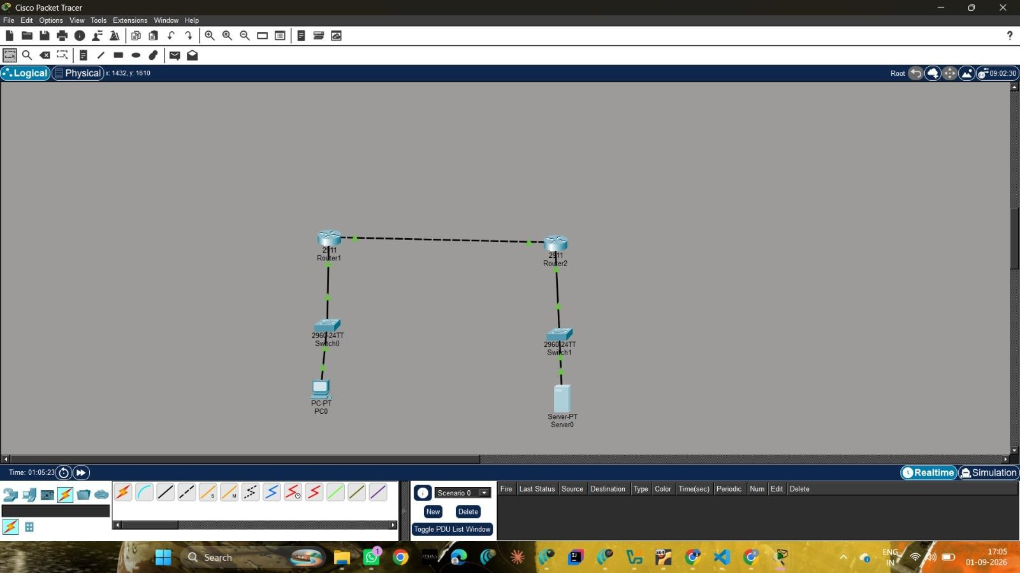

CONCLUSION
The experiment demonstrated the configuration of a basic hybrid cloud connectivity scenario using routers, switches, an end device and a server. Static routes enabled traffic to travel between the 192.168.1.0/24 and 10.0.0.0/24 networks.

